TECHNICAL REFERENCE MANUAL

Table of Contents
README Document: 2
Database Structure 5
Java Development Guide 6
Configuration data 7
Enabling Automated History for a Database Table 8
Value Objects 9
Cometd Message Handler 9
Service Methods 9
Cometd Security Policy 10
System Event Logger 10
JMS Messaging 10
Todd, any additions? 10
JavaScript Development Guide 11
Cometd enabled components and channels: 11
Processing the response: 12
Passive Components 13
Editor Groups and Editors: 14
Creating a New Node Type through inheritance: 16
Instantiating a node on the fly: 16
Node Removal and Clean Up: 16
How to generate HTML documentation for JavaScript 16
Channel Naming Standards: 19
How to Customize Messages: 20

README Document:
ActionCenters System Setup and Configuration:

Outlined below will be the various steps involved for setting up the environment to foster the use of the ActionCenters development.

You will need a standard distribution of Linux. 100 Gig of hard drive space will be sufficient. Install your distribution of Linux. And, of course, store your root password in a secure place. Software that will need to be installed is as follows:

Apache2
Java 1.6
Mysql 5.1
http://dev.mysql.com/downloads/mysql/5.1.html#downloads
Pick the appropriate one for your distribution.
Download the server portion into /tmp
From /tmp: rpm –i <package name>
It will then give you:

PLEASE REMEMBER TO SET A PASSWORD FOR THE MySQL root USER !
To do so, start the server, then issue the following commands:

/usr/bin/mysqladmin -u root password 'new-password'
/usr/bin/mysqladmin -u root -h centos password 'new-password'

Alternatively you can run:
/usr/bin/mysql_secure_installation

which will also give you the option of removing the test
databases and anonymous user created by default. This is
strongly recommended for production servers.

See the manual for more instructions.

Please report any problems with the /usr/bin/mysqlbug script!

The latest information about MySQL is available at http://www.mysql.com/
Support MySQL by buying support/licenses from http://shop.mysql.com/

Starting MySQL..[ OK ]

Alternatively, for Redhat, fedora or CentOS, you can ‘yum install mysql-server mysql’ and take the defaults. This may give you only version 5.0 of mysql, but that is fine. You will then have to, as root, do the following:

chkconfig mysqld on
/etc/init.d/mysqld start
mysqladmin -u root password ‘<new password>’ (can also be done from MySQL administrator, which is installed below.)

MySQL Administrator & MySQL Query Browser can be downloaded at:
http://dev.mysql.com/downloads/gui-tools/5.0.html

Once these are installed, remove the anonymous user and the test database (catalog).

Databases & Users:

Default admin user: This user will be created automatically up on the ActionCenters system starting up and detecting no users in the users table. Login is “Admin” and password is the same, case sensitive.

Create aclogging database and create an acloguser user with password of aclogpassword and assign acloguser all privileges on the aclogging database. The configuration file for this is in actioncenters-dbactivitylogging/src/main/resources/actioncenters-dbactivitylogging.xml.

Create actioncenters database and create an ActionCenterUser (case sensitive) user with password of ActionCenterPassword (case sensitive) and assign ActionCenterUser all privileges on the actioncenters database. The configuration file for this is in actioncenters-udm/src/main/resources/actioncenters-udm.xml.

jetty-hightide-7.1.6.v20100715
http://dist.codehaus.org/jetty/jetty-hightide-7.1.6/
download the .tar.gz file into /tmp
gunzip the file
place it in /usr/share
tar tar –xvf jetty-hightide-7.1.6.v20100715.tar
Should now be installed in /usr/share/jetty-hightide-7.1.6.v20100715
Place ActionCenters.war file in /usr/share/jetty-hightide-7.1.6.v20100715/webapps
Start jetty via “java –jar start.jar &” from /usr/share/jetty-hightide-7.1.6.v20100715
Should deploy properly.

Default application properties:

When the application is deployed, it will use the default application properties file which is stored in:

actioncenters/src/main/resources/application.properties

If you wish to override certain properties, you can create another properties file on the system and supply it as
a parameter to the jvm when starting the servlet engine (Jetty). Any properties not included (overwritten) in the overriding properties file will fall back to the default values in the default application.properties file.

To override some of the properties, start Jetty in the following manner:

java –Dconfig=file:///path/to/<configuration-file-name> –jar start.jar

As an example, here is what we used for the constantly updated 3rd iteration as we worked and updated the code:

java –Dconfig=file:///usr/share/jetty-7.0.0.pre5.8083/acconfig/iteration.properties –jar start8083.jar

Email:

An SMTP server is required. To enter this information, it will depend on your environment

Ports:

Disable port 22 (telnet) for security reasons if you’d like.
Enable port 8080 for jetty. If port 8080 is not available, enable a different port and make a change in the
/usr/share/jetty-hightide-7.0.1.v20091125/etc/jetty.xml file and change 8080 to the port you now have open.

Database Structure
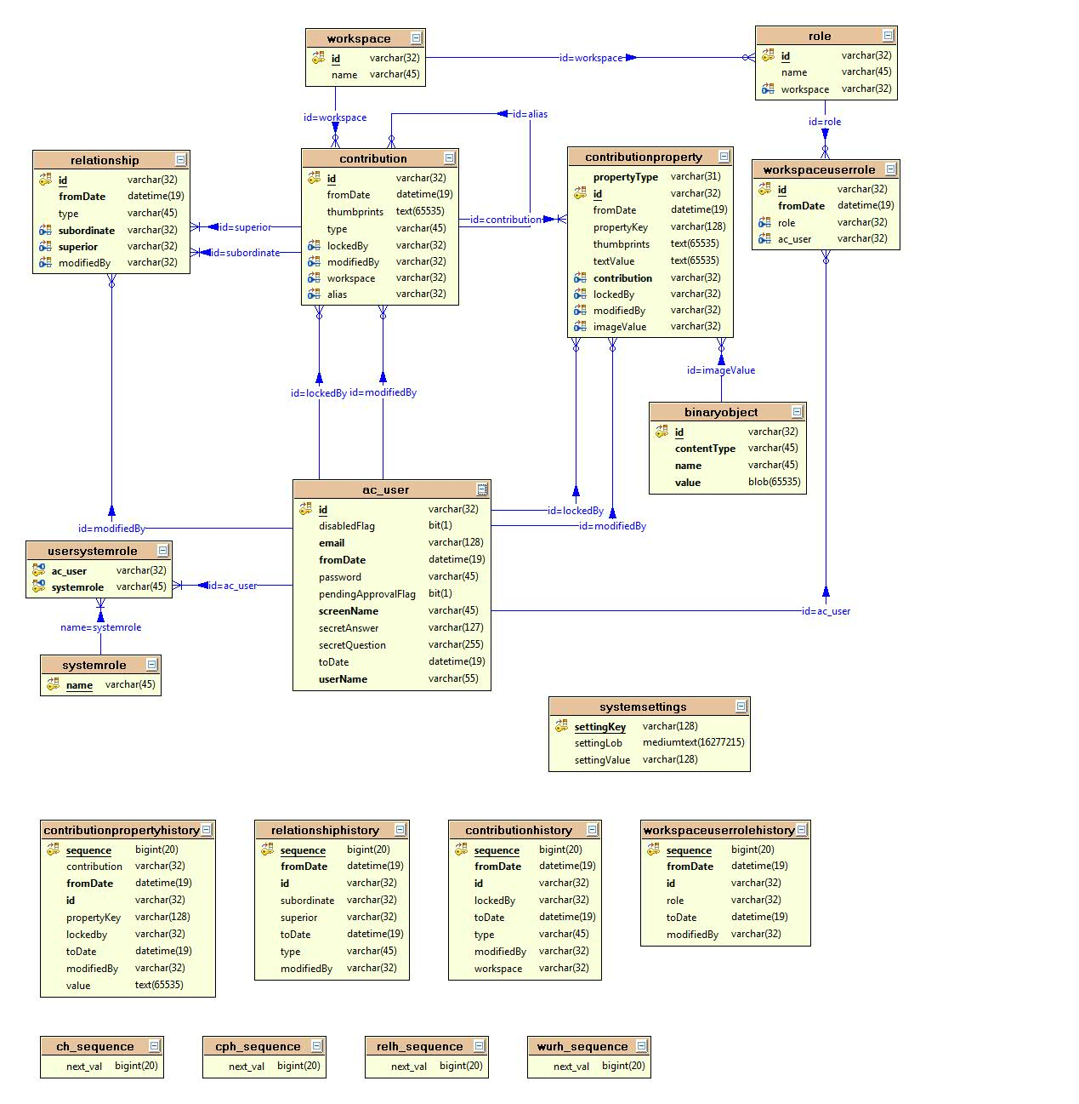
Java Development Guide
ActionCenters uses Service-Oriented Architecture:
- At the front-end, servlets and JavaScript display content and gather user input;
- User input is forwarded to a listening/notification service;
- The service invokes a store procedure on Universal Data Model (UDM) objects;
- At the back-end, the state of UDM objects is saved in a relational database using Hibernate.

Data communication between JavaScript and Java is handled by Cometd service. Messages are formatted in JSON data format that is similar to comma-separated records. JSON messages are parsed and their content is stored in Java Value Objects (VO). Value objects are queried by a contribution service and all changes are stored in a database.

There are several key classes that form the backbone of all user interactions in ActionCenters; each of the italicized words is the name of a class: A User working in a Workspace makes a Contribution in some Role. Each contribution may have one or more Contributionproperty elements. Contributions may be related to each other by Relationships. User interactions subject to historical tracking are saved in history classes:
- Contributionhistory
- Contributionpropertyhistory
- Relationshiphistory
- Workspaceuserrolehistory

Java source code is divided into several packages/projects:
- actioncenters – contains web application files including servlets, JSP and JavaScript source files
- actioncenters-core – defines interfaces, exceptions, and core classes (Value Objects)
- actioncenters-udm – defines classes and services to interact with a database
- actioncenters-contributionnotification – defines ContributionNotificationService class
- actioncenters-project – place-holder package for running Maven builds
- actioncenters-mqmessaging – defines messaging classes
- actioncenters-mqactivitylogging – defines messaging services
- actioncenters-dbactivitylogging – defines activity logging classes and services

Application building tasks like cleaning, compiling, testing, and packaging are performed using the Maven tool. Maven is similar to Ant with respect to functionalities and provides automatic tracking of dependencies in the source code.

Each project has a folder structure that is compliant with Maven’s structuring of projects:
- src/main/java – Java source files
- src/main/resources – bean configurations, property files, logging configurations
- src/test/java – JUnit test files
- src/test/resources – resource files used by tests
- target – location for compiled binaries
- src/main/webapp – JavaScript (.js) and JavaServerPage (.jsp) source files

Each project has a ‘pom.xml’ configuration file under the root folder that defines dependencies that are needed to build the project. Each of the individual projects can be built individually by right-click + Run As + Maven install. The main project ‘actioncenters-project’ defines all of the individual projects as Maven modules so building the main project will build all projects.

Each new method added to the Java source needs to be tested using JUnit tests. Naming conventions and annotations should follow JUnit style. See existing tests in src/test/java subdirectories of individual projects for examples.

The master version of the source code is kept in an SVN (similar to CVS) repository at svn:// actioncenters.svn.sourceforge.net. The latest code is located under svnroot/actioncenters/trunk/AC. Before a source code change can be committed to the repository, all compiler errors and test failures need to be diagnosed and removed locally so that they are not propagated to others. This can be done by clean-rebuild cycle in MyEclipse and clean-install cycle with Maven.

Configuration data
Property files (.properties) contain mappings of the form ‘key=value’, whose keys are used by JSP and JS code to avoid hard-coding values: e.g.
- actioncenters-messages.properties – various message strings
- actioncenters-html.properties – labels used on buttons, links, columns and text fields
- actioncenters-errors.properties – error message strings
- actioncenters-regexp.properties – regular expressions for validation of user input
- application.properties – configuration settings for logging into local databases

XML configuration files (.xml) define beans, whose identifiers can be referenced from Java source code to retrieve a class name or a property defined by a bean.

Here is an example of how bean information is retrieved from the source code:

Excerpt from SystemSettingsService.java
public class SystemSettingsService implements ISystemSettingsService {
/** The Application Context. */
private static ApplicationContext ac = ApplicationContextHelper.getApplicationContext("actioncenters-udm.xml");
public String getElementMetadata() {
SystemsettingsDAO systemSettingsDAO = SystemsettingsDAO.getFromApplicationContext(ac);
Systemsettings systemSettings = systemSettingsDAO.findById(ELEMENT_METADATA_KEY);
...
}
...
}

Excerpt from SystemsettingsDAO.java
public class SystemsettingsDAO extends HibernateDaoSupport {
...
public static SystemsettingsDAO getFromApplicationContext(ApplicationContext ctx) {
return (SystemsettingsDAO) ctx.getBean("SystemsettingsDAO");
}
}

Excerpt from actioncenters-udm.xml
<beans ...>
<bean ...> ... </bean>
<import resource="actioncenters-udm-db.xml"/>
</beans>
Excerpt from actioncenters-udm-db.xml
<bean id="SystemsettingsDAO"
class="org.actioncenters.udm.data.SystemsettingsDAO">
<property name="sessionFactory">
<ref bean="sessionFactory" />
</property>
</bean>
In this example, SystemSettingsService.getElementMetaData() instantiates class SystemsettingsDAO indirectly by referring to an application context, which retrieves the class name from the configuration file and instantiates the class. The main advantage of using such indirection is to enable easy insertion of new code for SystemsettingsDAO by changing the name of the class in the bean to a new class name.

The file actioncenters-udm-db.xml defines beans for hibernating state of UDM classes
- parameters needed to connect to a DB: notation of “${udm.datasource.driverClassName}” refers to property udm.datasource.driverClassName defined in application.properties file
- settings needed by hibernate session factory for sessions with a DB
- mapping keys to class names

The file actioncenters-dbactivitylogging-db.xml defines beans for hibernating activity logs.

Enabling Automated History for a Database Table
We have developed an approach to saving history data for tables that is independent of the database provider. This is enabled by a couple of listeners that “intercept” hibernate’s processes. Data is saved to a separate history table that has a structure that mirrors the table being “historized”. In order to make a table that is “historized” you must complete the following tasks:
- The table to be archived must have a fromDate field of type datetime.
- Create a history table whose name is <tablename>History. It should basically be a mirror of the table being archived, containing all of the columns of the main table. This table should also have one additional column, named “sequence” which is bigint(20). Make this the key of the table.
- The Entity class must implement “HistoryEnabled” and the Entity class of the corresponding History table must implement “HistoryObject”.
- Implement the buildFromOriginal method in the new Entity class. This method basically builds an instance of the <tablename>History object from the data in the table preceding the update being executed.
  - Set the fromDate of the history record to the original fromDate.
  - Set the toDate of the history record to the fromDate of the dirty entity record.

Value Objects
The primary data objects of ActionCenters are specified by the org.actioncenters.core.contribution.data package and are implemented by the org.actioncenters.core.contribution.data.impl package. These data objects are
- ValueObject
- Contribution
- ContributionProperty
- Relationship
- User
- Workspace
- Role
- SystemRole

Each object has attributes along with getter and setter methods in the JavaBean style. To communicate the state of a data object between Java and JavaScript, the values of object attributes are inserted into a value map of type Map<String,Object>, which maps attribute names to attribute values. The value map is then passed onto the Cometd service, which publishes it to listening channels for distribution to JavaScript clients.

Cometd Message Handler
The class org.actioncenters.cometd.CometdService is the entry point from JavaScript to Java and vice versa. JavaScript sends messages on Cometd channels. The messages contain “action” attributes, which designate the name of a Java method to invoke upon the receipt of the message. Hence, when the Cometd service handles requests and parses received messages, it will invoke the specified action method passing the rest of the message contents onto the method. The action method parses the message and invokes methods of the middle-tier services such as ContributionService, UserManagementService and SystemSettingsService.

Service Methods
ContributionService is specified in the org.actioncenters.core.contribution.svc package and is defined in the org.actioncenters.udm.svc package. The main purpose of ContributionService is to perform CRUD (create, read, update, delete) operations on users’ contributions.

UserManagementService is specified in the org.actioncenters.core.usersecurity package and is defined in the org.actioncenters.udm.svc package. The main purpose of this service is to perform CRUD operations on users’ roles.

SystemSettingsService is specified in the org.actioncenters.core.system.settings package and is defined in the org.actioncenters.udm.svc package. This service manages system settings such as configuration of ActionCenters GUI elements.

ContributionNotificationService is specified in the org.actioncenters.core.contribution.svc.notification package and is defined in the org.actioncenters.contributionnotification package. This service notifies all listeners that are registered with the service about add, remove and update events on contributions and relationships among contributions. Hibernate provides DefaultSaveOrUpdateEventListener and DefaultDeleteEventListener classes, which contain onDelete and onSaveOrUpdate methods that are triggered any time Entity classes change. We override these methods in the org.actioncenters.udm.history package and notify the listeners registered with the ContributionNotificationService.

Cometd Security Policy
org.actioncenters.cometd.SecurityPolicy

System Event Logger
actioncenters.xml
activityLoggingAdvice, userManagementLoggingAdvisor, contributionManagementLoggingAdvisor

JMS Messaging
actioncenters-mqmessaging (requires a lot of explanation)

Todd, any additions?

JavaScript Development Guide

Cometd enabled components and channels:
When a component is cometd enabled, there are two main methodologies that can be used. One is when a component is passive, but always listens for a change. Another is when the component is responsible for initiating a change, and behaves more as a request and response object (active component).
An active component quite often is a form, or a button, or a menu item. The user interacts with these components to initiate a change. The change itself is often displayed by a passive component, but often the active component needs a response as well. I’ll give an example. When a user wants to add a project in the CACE tool, they click on create a project button and this opens a form. This form allows you to enter 3 pieces of data (name, description, and URL). This form is an active component, because once you fill the information out, you will submit that change server side. When you submit the change, you want to listen for the result of the change, to see if it was successful, or if not, what error messages need to be displayed to the user. If there are errors, only the person making the submission should get the error back. If the submission is successful, all passive components, like the tree explorer nodes, should be notified to add a new tree node. I’ll walk through the steps of what takes place on most active components:
- A component is created and displayed for the user to interact with. (like a form in a pop up window)
- When a user hits submit, we immediately subscribe to a channel where we can listen for the response.
- If the submission was an error, we display that error on the popup form and unsubscribe from the channel.
- If the submission was successful, we unsubscribe from the channel and close the popup form.
Notice how we unsubscribe immediately after we get the result. We do not want to leave subscriptions open on active components. This can cause unexpected results where a function may get executed twice (if two duplicate subscriptions are in place) or an error occurring (if a message comes back and we try to run a function that may not exist on the page).
If an active component does not do any processing, we send in a channel called /noresponse and simply don’t listen for a change to take place. This is often done for simple actions that don’t require a display, even if there is an error. Delete project is currently an active function that does not display an error. In the future, there may be a default area on the page to display all errors, and we may begin monitoring success or failures on these components.
Here is the code for creating a project with the steps explained.

var channel = "/response/" + dojox.cometd.clientId + "/addProjectResult";
This channel is the channel that our component is listening for a response on. The channel includes a unique clientId, which will ensure that only the user gets the message back for this response.
dojox.cometd.subscribe(channel,Ext.getCmp('newProjectWindow'),'displayServiceError');
Here we are subscribing to this channel, and when we get a response, we want to call the ‘displayServiceError’ method on the window with the form in it.
var projName = Ext.getCmp('newProjectWindow').findById('projectName').el.dom.value;
//calls a function that gets the next project name
dojox.cometd.publish("/requests/service", {
action : "createProject",
ParentId : treeRootId.id,
user: workspaceUser,
receivingchannel : channel,
id: '',
projectName: Ext.getCmp('newProjectWindow').findById('projectName').el.dom.value,
projectDescription: Ext.getCmp('newProjectWindow').findById('projectDescription').el.dom.value,
projectURL: Ext.getCmp('newProjectWindow').findById('projectURL').el.dom.value
});
Above we are creating the actual content of the message that will be sent server side to be processed. We are publishing on a channel /request/service which is the channel the server is listening to for messages.
Action is createProject, which gets interpreted server side to run a particular method that will actually add the project. ProjectName, projectDescription, and projectURL are all attributes for the project to be added. ParentId is the id of the workspace that this user has open, and the project will be added to the workspace so that it will show up on any passive channels that should display the project. User is the username of the user making the change. Receiving channel is the channel that this method should publish any error or success messages.

Processing the response:
This section of code is defined on the window that sends the message.
displayServiceError: function(msg){

if(msg.data.result == 'success'){

Ext.getCmp('newProjectWindow').close();

}
If the message says that the createProject function was successful, we will close the window.

else {

//display the error here.
var error = 'Populate Error';
Ext.getCmp('projectError').setText(msg.data.errorstring,false);
Ext.getCmp('projectError').show();
}
If the message was not successful, we will diplay that error in the window.

var channel = "/response/" + dojox.cometd.clientId + "/addProjectResult";
dojox.cometd.unsubscribe(channel,Ext.getCmp('newProjectWindow'),'displayServiceError');
}
No matter what, unsubscribe from the message. We will automatically be re-subscribed if the user hits the submit button again. This way if the user closes the window we won’t have a subscription to a javascript component that is no longer active on the page.

Passive Components
Passive Components exist on the page for an extended period of time, and while they exist, they are always listening for updates. A passive component usually listens on at least three (3) channels and sometimes more. It listens to an edit channel so that it can make changes to itself, listens on an add channel so that it can add a child component, and listens to a delete channel so that it can delete a child component. There may be more listeners in the future, perhaps like a sort or reorder channel. If a passive channel is deleted, it needs to delete all its listeners, and if it has children, needs to unregister its children as well. This is a recursive process.
dojox.cometd.startBatch();
dojox.cometd.subscribe("/contributions/relationship/" + explorerRoot.id + "/childof/AC_Project_Definition/add", explorerRoot.attributes,'createChild');

dojox.cometd.subscribe("/contributions/relationship/" + explorerRoot.id + "/childof/AC_Project_Definition/delete", explorerRoot.attributes,'deleteChild');
dojox.cometd.endBatch();
Above is the code for subscribing a component to listen for adding or deleting a child component. In this case the object that is listening is explorerRoot, and the methods that add or delete children are in .attributes.createChild() and .attributes.deleteChild(); The Explorer Root is invisible, so it does not listen for changes to itself, but most components will have methods to change itself.
createChild : function(msg){
var id = msg.data.contribution.id;
var projectText = msg.data.contribution.contributionProperties.projectName.value;
Get the data from the message coming back from cometd and assign it to javaScript variables.

var existingchild = Ext.getCmp('treeExplorer').getRootNode().findChild("id",id);
Check to see if that component already exists in the tree, and if so, we don’t want to re-add it.

if(existingchild == null) {
var projnode = new actioncenter.projectNode({
text:projectText,
id: id,
cls:'x-tree-node-actioncenter',
targetTabPanelId:'workbenchPanel',
uiProvider: actioncenter.projectNodeUI
});
Create the actual tree node using the data from the message.
Ext.getCmp('treeExplorer').getRootNode().appendChild(projnode); projnode.subcribeAllChannels();
Append this new node to the tree, and then call its subscribe method to so it will be registered with cometd.
}
return;

},

deleteChild : function(msg) {
var childId = msg.data.contribution.id;
var node = Ext.getCmp('treeExplorer').getRootNode().findChild('id',childId);
if(node != null) {
Gets the node that should be removed and checks to see if it is actually there.
node.unsubscribeAllChannels();
Ext.getCmp('treeExplorer').getRootNode().removeChild(node);
Unsubscribe all the Cometd listeners and then remove the node.
}

var workbenchopen = Ext.getCmp('workbenchPanel').findById(childId + '-tabpanel');
if(workbenchopen != null) {
Ext.getCmp('workbenchPanel').removeAll();
}
In this case, when a project node is deleted, it should also remove the editor for the project if it is open.
return;
},

Editor Groups and Editors:
For each major type of object in the CACE tool, there can be multiple editors. A major type of object can be anything that makes up a structure of a project, including the project itself, and activities, roles, screens, etc. The founding developers will develop the initial editors, but we want future developers to be able to plug new editors in without having to worry about touching the base code.
When a user double clicks on an object in the explorer tree, a tabbed panel will open, with a panel on the top of the workspace. For each editor for the object, there will be a panel at the bottom of the panel. Included is a screen shot.

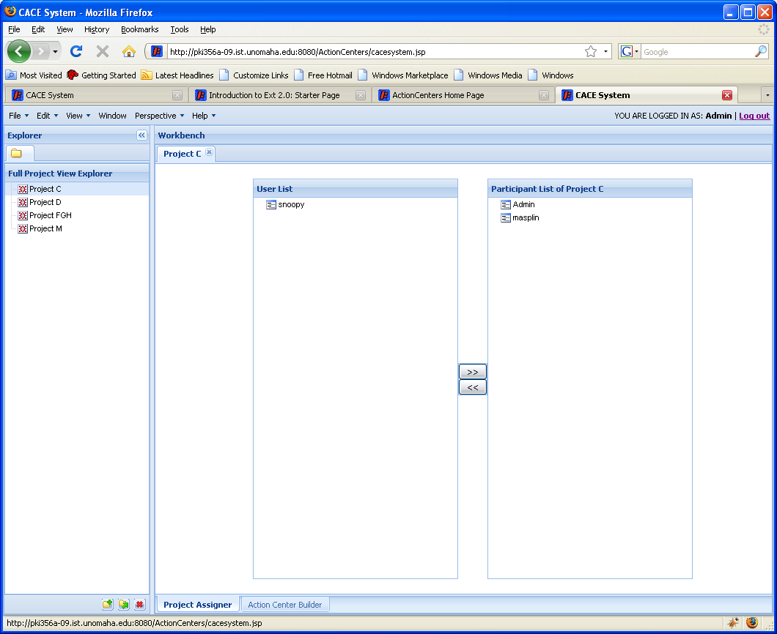Figure 1.1
In the above case, a user double clicked on Project C, and a Project Group was opened with a tab on top. Two editors were included, and there are tabs at the bottom of the editor group for each one: Project Assigner and Action Center Builder. The editor we are looking at is the Project Assigner.
To enable this dynamic addition of editors, the opening of the editor group is hard wired to the project, but then an editor opens for each editor object that is registered to a project editor. I will include code below that shows you how to create an editor and how to register it. Once this process is complete, it automatically is included as an editor.
actioncenter.acBuilder = Ext.extend(Ext.Panel, {
title: 'Action Center Builder',
projectID:'',
projectName:'',
layout:'fit',
html:'<p>This is a action center builder panel </p>',
initComponent : function(){
var projectID = this.projectID;
}
///all the other stuff it does.
});

Each Editor extends panel and then anything that is inside the editor would be built in the initComponent function. Each editor is passed an id, in this case a project id, which is the id of the project that was double clicked. This id should be used to create the content for the editor.

actioncenter.ProjectTypeArray.register(actioncenter.acBuilder);
??? Put in registry types ???
There will be a registry for each type of editor, above is the project registry example. There should be a comprehensive list published, probably included in this development guide. To include the editor in a editor group, you simply register the editor with the appropriate group.

Creating a New Node Type through inheritance:
??? Write about new nodes ???

Instantiating a node on the fly:
??? Write stuff here ???

Node Removal and Clean Up:
??? Put in more stuff ???

How to generate HTML documentation for JavaScript
The JavaScript (JS) source code contains javadoc-like documentation comments describing the functionality of the source code in verbose plain text. The comments follow a pre-defined structure, which allows one to generate HTML documentation of the JS code for use by developers and users of ActionCenters.

We use JSDoc-ToolKit (the toolkit) to generate the HTML. As of this writing, Maven plug-ins based on the toolkit do not support exclusion of source files (e.g. dojo and extjs), which are external to ActionCenters. Therefore, we use the toolkit separately from the Java documentation generation (doc-gen) procedure, which uses Maven’s site plug-in (the “mvn site-deploy” command).

Procedure
Download the latest version of the toolkit (e.g. 2.3.2) from
http://code.google.com/p/jsdoc-toolkit/downloads/list

Unzip the downloaded archive locally: e.g.
C:\Program Files\Java\jsdoc_toolkit-2.3.2\jsdoc-toolkit

In the MyEclipse Java Enterprise perspective, open the menu
Run – External Tools – External Tool Configurations

In the pop-up window, select “Program” in the left pane, and click “New launch configuration” in the top left corner.

For Location, insert
C:\<path to jdk>\bin\java.exe
e.g. C:\Program Files\Java\jdk1.6.0_12\bin\java.exe

For Working directory, insert
C:\<path to the toolkit>\jsdoc-toolkit
e.g. C:\Program Files\Java\jsdoc_toolkit-2.3.2\jsdoc-toolkit

For Arguments, insert
-Xms512m -Xmx1024m -jar jsrun.jar app\run.js -v -a -p -E="(dojo)|(extjs-3.3.1)" -r=15 "C:\<path to the workspaces>\Workspaces\MyEclipse\AC\actioncenters\src\main\webapp" -t=templates\jsdoc
-d="C:\ <path to the workspaces>\Workspaces\MyEclipse\AC\actioncenters\target\jsdocs"

Note: for explanation of the arguments, see
http://code.google.com/p/jsdoc-toolkit/wiki/CommandlineOptions

Leave all other settings at their defaults. Here is a sample configuration:

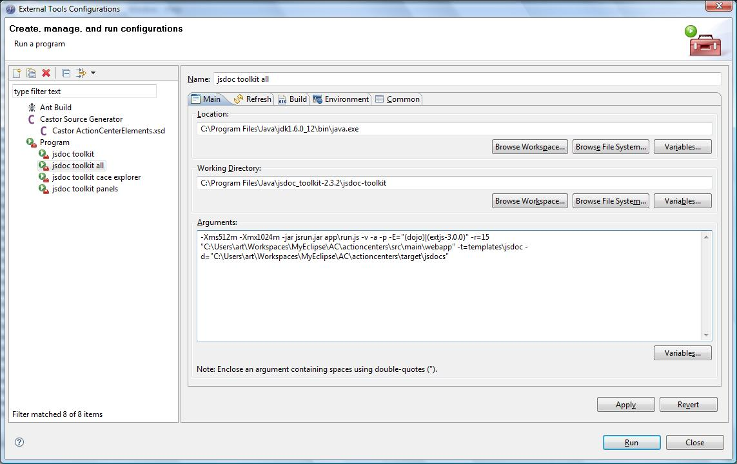

Click Apply, and then Run.

Due to the size of the source files, the execution might take several minutes. Upon completion, the index.html file in the output directory is the starting point for browsing the generated HTML documentation.

The format of JS doc comments and the tags are explained on the following page:
http://code.google.com/p/jsdoc-toolkit/wiki/TagReference

Alternatively, you can browse the source code to see the examples of the doc comments and the generated HTML pages.

Channel Naming Standards:

Listeners
These are channels on which messages will be sent under the following circumstances:

- Relationship to Contribution Added
  - /contributions/relationship/<superior contribution ID>/<relationship type>/<subordinate contribution ID>/add
  - /contributions/relationship/<superior contribution ID>/<relationship type>/<subordinate contribution type>/add
  - /contributions/relationship/<superior contribution ID>/<relationship type>/**
    - ** is a wildcard
- Relationship to Contribution Deleted
  - /contributions/relationship/<superior contribution ID>/<relationship type>/<subordinate contribution type>/delete
  - /contributions/relationship/<relationship ID>/delete
  - /contributions/relationship/<superior contribution ID>/<relationship type>/<subordinate contribution ID>/delete
  - /relationships/relationship/<relationship ID>/delete
- Contribution Updated
  - /contributions/contribution/<contribution ID>/update
  - /contributions/contribution/<contribution ID>/<user ID>/thumbprints
    - Message is sent on this channel to the user when user’s id has been added to the thumbprints for the contribution with the id <contribution ID>
- Contribution Deleted
  - /contributions/contribution/<contribution ID>/delete
- Contribution Property Updated
  - /contributions/contribution/<contribution ID>/property/<property key>/update
- Contribution Property Deleted
  - /contributions/contribution/<contribution ID>/property/<property key >/delete
- Swapper Channel
  - /contributions/contribution/swapper/<contribution Id>
- Add User to System Role
  - /contributions/relationship/systemuser/childof/<system role>/add
- Remove System User Channel
  - /contributions/relationship/systemuser/childof/<system Role Name>/delete
- User Message Channel
  - /ActionCenters/message/<severity> (where severity is debug, info, warning, or error)

Operations

- Channel Name
  - Message contents

How to Customize Messages:

There are four main files used in the actioncenters project to define on-screen prompts and error messages. The four files are defined in actioncenters/src/main/resources/actioncenters.xml and stored in this same subdirectory:

<bean id="messageSource" class="org.springframework.context.support.ResourceBundleMessageSource">
<property name="basenames">
<list>
<value>actioncenters-messages</value>
<value>actioncenters-errors</value>
<value>actioncenters-html</value>
<value>actioncenters-regexp</value>
</list>
</property>
</bean>

When a standard or error message is needed in the system, it will be in one of these four files. If optional messages are needed for additional languages, individual messages can be overridden by placing the overriding name-value pairs in files named as above but with a ‘_<language>’ format. These files are to also be included in the /actioncenters/src/main/resources directory. In other words, we can have an ‘actioncenters-messages.properties’ file as well as an ‘actioncenters-message_fr.properties’ file for French overrides. Any name-value pairs in the optional language file will override any of the standard messages.

The ResourceBundleMessageSource gets the current language setting from the client’s browser. For example, in Firefox, under Tools → Options … → Content tab, you can choose the language you would like to use. In adding the optional languages, you can see the <language> suffix to be used on the above files in the square brackets. You can then select a language other than English-US, and move it up to the top as the priority language.

